# Tables – HIC1

Sarah Nguyen, the owner of the Spotted Wren Garden Center, has given you additional content to add to the website you’ve been creating for her. You add this information using lists and tables.

1. Open HTM_H-8.html and save it as **resource.html**
2. Open HTM_H-9.css and save it as **styles.css**
3. In the comment at the top of each file, enter your name and today’s date where indicated, then save the files.
4. **resource.html**:
   1. Beneath the h3 heading *Omaha area plant hardiness zone information*, insert the following table. (*Hint*: Use rowspan attributes for the cells containing the text *Zone, Last frost, First frost, May 1*, and *Oct 15*. Use a colspan attribute for the cell containing the text *Average annual minimum temp*. The HTML character code for the degree symbol is &deg;).

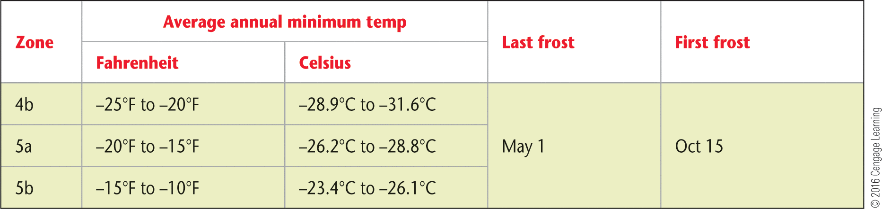

* 1. Save the changes to resource.html

1. **styles.css**
   1. In the reset styles section add the table, thead, tbody, th, and td selectors to the list of selectors in the style rule that sets border, padding, and margin to 0.
   2. At the end of the reset styles section, create a style rule using the table selector that collapses borders and sets border spacing to 0.
   3. Above the /* footer section */ comment, add a comment containing the text **main content table**. Below the comment, add a style rule for th and td elements that creates a 1px solid black border and sets the padding to 0.5em, then add a rule for th elements that sets the background color to yellow.
   4. Save the changes.
2. **resource.html**
   1. In the code for the table, add **class** names to display the colors shown in the example. There should be two color classes, one for the green (#87f547) and one for the salmon (#f5a88c) colors.
   2. Save the changes
3. **styles.css**
   1. In the main content table section add a style rule for the **class** that sets the background color to #87f547
   2. Add a style rule for the class that sets the background color to #f5a88c.
   3. Save the changes
   4. Reload resource.html in the browser and verify that the table appears as shown below.

